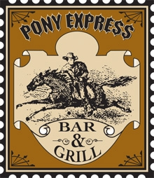
Come join us for a special Halloween evening
featuring the…
The Crimestoppers
ARRESTING ROCK AND BLUES

Playing 8:00pm ~ 12:00am
Saturday, October 31st, 2009
At the Pony Express Bar & Grill
Located in the reception building

Great Drink specials all night!
$10 any large pizza all night!



9600 Newbridge Drive, Potomac, MD 20854
www.bolgercenter.com

